Chosho ji

shiizan Chōshō-ji (石井山長勝寺?) is a Buddhist temple of the Nichiren sect inKamakura, Kanagawa, Japan^{[1]}. It's one of a group of three built near the site in Matsubagayatsu (Valley of Pine Needles (松葉ヶ谷?)^{[2]} where Nichiren, founder of the Buddhist sect that bears his name, is supposed to have had his hut. The first part of its name derives from the founder's last name (Ishii), the second is an alternative reading of the characters for Nagakatsu, the founder's first name^{[3]}.

Nichiren, Matsubagayatsu and Chōshō–ji
Kamakura is known among Buddhists for having been during the 13th century the cradle of Nichiren Buddhism. Founder Nichiren wasn't a native: he was born in Awa Province, in today's Chiba Prefecture, but it was only natural for a preacher to come to Kamakura because at the time the city was the cultural and political center of the country^{[4]}. He settled down in a hut in the Matsubagayatsu district where three temples (Ankokuron-ji, Myōhō–ji, and Chōshō-ji), have been fighting for centuries for the honor of being the sole heir of the master^{[4]}. All three say they lie on the very spot where he used to have his hut, however none of them can prove its claims. TheShinpen Kamakurashi, a guide book to Kamakura commissioned by Tokugawa Mitsukuni in 1685, already mentions a strained relationship between Myōhō–ji and Chōshō-ji^{[5]}. However, when the two temples finally went to court, with a sentence emitted in 1787 by the shogunate's tribunals Myōhō–ji won the right to claim to be the place where Nichiren had his hermitage^{[5]}. It appears that Ankokuron-ji didn't participate in the trial because the government's official position was that Nichiren had first his hut there, when he first arrived in Kamakura, but that he made another near Myōhō–ji after he came back from his exile in Izu in 1263^{[5]}. What Chōshō-ji claims are the remains of the hut lie near the entrance of the Zaimokuza Reien cemetery, outside the temple's premises^{[1][6]}.
The temple was built by Ishii Nagakatsu, lord of this land in 1263, ten years after the other two^{[1]}. Even if it was really originally built together with Ankokuron-ji and Myōhō–ji by Nichiren himself when he entered Kamakura, the present temple is however simply a later reconstruction by someone else^{[1]}. Whatever the truth, Chōshō-ji seems therefore to be the party in the dispute with the weakest arguments.

Features of the temple
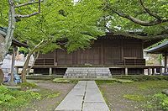

Chōshō-ji's Hokke-dō
Next to the temple's gate stands a huge statue of Nichiren himself surrounded by four Deva Kings, who are there to protect and serve him^{[3]}.
Because at the time of his persecution Nichiren was saved by a white monkey, believed to be a retainer of god Taishakuten, the great building behind the statue (the Taishaku-dō) is dedicated to him^{[3]}.
A little above the Taishaku-dō stands the Hokke-dō, a small building which is the temple's de facto main hall^{[3]}. The building, originally built during the Muromachi period, is an Important Cultural Property^{[3]}. It contains three more Important Cultural Properties, a gong (waniguchi), a lacquered dining table (kakeban), and a candle stand (shokudai)^{[3]}.
Every year on February 11 the temple hosts the Daikokutōe Seiman Matsuri (大国祷会成満祭り?) Ceremony during which Buddhist priests douse themselves with cold water to pray for the country's safety^{[7]}. About 150 Nichiren priests from all over the country come here for the ceremony, participation to which being a precondition to be allowed to perform religious services^{[3]}.

Historical Overview
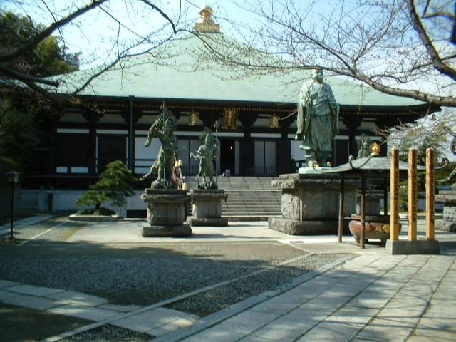
Nagakatsu Ishii (birth and death years unknown) , the founder of the Temple, was the lord of a manor here and a faithful follower of Priest Nichiren (1222-1282), the founder of Nichiren sect Buddhism. When Priest Nichiren came back to Kamakura in 1263 after deportation to the Izu Peninsula, Ishii cordially accommodated him with a hermitage inside Ishii's manor, which was later expanded to a temple called Honkokuji.
However, Honkokuji was relocated to Kyoto in 1345 at the request of Takauji Ashikaga (1305-1358), who established the Ashikaga government in Kyoto. It was Priest Nissei (1289-1369), an important Nichiren Sect Buddhist, that reconstructed the Temple at the site where Honkokuji had existed earlier. 'Chosho-ji' was named after Ishii's first name 'Nagakatsu', which can also be called 'Chosho' in Chinese characters. That is the origin of what we see today.
Like Myohoji and Ankokuronji in the vicinity, the Temple also claims that Priest Nichiren's hermitage in Kamakura had existed right here, though various records indicate otherwise.
Five Bronze Statues
Standing in the Temple's courtyard are five magnificent bronze statues. Surrounded by the Four Devas, or gods of four directions, (Shitenno in Japanese), and installed right in the center is a 4-meter-tall statue of Priest Nichiren himself. Made in 1922 by Ko-un Takamura (1852-1934), a famous sculptor in the early 20th century, in commemoration of Priest Nichiren receiving an honorable title 'Rissho Daishi' from the Imperial Court, it shows the Priest's pose delivering his speeches at a busy street corner in Kamakura. It used to stand on top of a hill behind the main hall facing east, to the direction of his home town in Chiba Prefecture. Being exposed to the sea breezes, it was brought down to the present site in 1982.
The Four Devas are believed to serve and protect Taishakuten, or Sakra devanam Indra in Sanskrit, and reside halfway up the Mount Sumeru of the Buddhist universe. Each Deva is given a mission to guard against evil influences at the specific direction allocated as follows:
- Jikokuten, or Dhrtarastra; Eastern guardian
- Komokuten, or Virupaksa; Western guardian
- Zochoten, or Virudhaka; Southern guardian
- Tamonten (also called Bishamonten), or Vaisravana; Northern guardian
In the case of the Temple, the Four Devas serve and protect Priest Nichiren, who are looking at the southeast, and therefore, the four statues here stand clockwise Zochoten, Komokuten, Tamonten and Jikokuten. All are clad in armors with threatening aspects. Four Devas at Yakushiji in Nara.
Taishakudo Hall
Behind the five bronze statues is a magnificent concrete building called Taishaku-do. Legend asserts that at the time Priest Nichiren was attacked by the mobs of other sect Buddhists in 1260, a white monkey approached him and the monkey helped him to evacuate. Priest Nichiren believed that the monkey must have been a divine emissary dispatched by Taishakuten to help him get out. Thus, the statue of Taishakuten is enshrined in this Taishaku-do hall as his guardian deity. In the center of the hall are the statue of Priest Nichiren and a pair of (not one) white monkeys holding the priest's hand in front of a huge Taho-to, or ratna-stupa.
Hokke-do Hall (Picture, below)
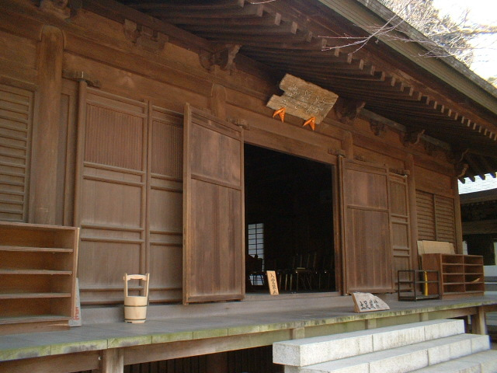
A flight of steps on the left-hand side of the courtyard leads to an old structure, nine meters square Hokke-do Hall, a.k.a. Soshido, (hall of the founding priest). Hokke-dodenotes a prayer hall for the Lotus Sutra and is dedicated to the memory of the founding priest. Originally, it was built in the Muromachi Period (1336-1573) modelling after the Chinese-style architecture and still maintains the original design. As de facto main hall of the Temple, it is an Important Cultural Asset designated by Kanagawa Prefecture. Enthroned on the altar are the statue of Priest Nichiren, behind which are the OdaimokuTablet, statues of Shaka (Sakyamuni in Skt.) and Taho Nyorai (Prabhutaratna Tathagata in Skt.), as is commonly seen in other Nichiren sect temples. The hall has ancient and valuable assets such as :
- Waniguchi: A round gong hung from eaves in front of the oratory at temples and shrines is called Waniguchi. It's a pinata-like shaker. A fat rope usually braided with cloth hangs in the middle. Worshipers shake it to rap gong and call attentions of deity. The Waniguchi here is made of copper. A picture of Waniguchi at Kawasaki City's Museum, Kanagawa Prefecture.
- Kakeban: A lacquered dining table. A picture of Kakeban at Koga city's website, Ibaraki Prefecture.
- Shokudai: A candle stand
All three are ICAs designated either by Kamakura city or Kanagawa Prefecture
.
Annual observances
February 11 (Holiday: National Foundation Day): Daikoku To-e, or austere discipline.
For 100 days beginning November 1 every year, young Nichiren sect priests who practice asceticism, gather at Nakayama-Hokekyoji in Ichikawa city, Chiba Prefecture and start to purify themselves by ablution, eating only vegetable food and practicing asceticism day and night. Suffering is considered a way to attain a religious goal. About 150 young Nichiren priests nationwide join this program. In the dead of winter, they get up at 2:30 a.m. and have cold-water ablutions seven times a day before going to bed at 11:00 p.m. With the austere exercises and poor food (only twice a day, usually with rice porridge and miso soup), all of them lose at least 10 kilograms in the end and suffer from vitamin deficiency syndrome. On the final day of February 11, some of them come to the Temple (by train from Chiba to Kamakura, and then walk), and finish the 100-day ascetic purity rite by pouring bone-chilling water upon themselves at 12:30 p.m. They wear only white loincloths. One of the most notable events during winter in Kamakura. Incidentally, Nichiren sect priests are not allowed to officially perform religious services without undergoing this discipline.
Incidentally, Nakayama-Hokekyouji is one of the most important temples for Nichiren sect and it keeps autograph manuscript of the famous treatise entitledPacifying the State by Establishing Orthodoxy Priest Nichiren wrote in 1260 when he was 39 years old. (Refer to Ankokuronji.)

