THEN AND NOW

Drenched in history: scenic Senzoku Pond

By SUMIKO ENBUTSU
The 1830s woodblock print shown here depicts Senzoku Pond in a southwestern suburb of Edo that is now part of Ota Ward, Tokyo.
A sudden rain falls fast, ruffling the surface of the pond. While those who are prepared for changeable weather, clad in raincoats or wearing hats, pace away undisturbed, less fortunate monks and porters take refuge in a thatched tea house, looking up nervously at the sky.
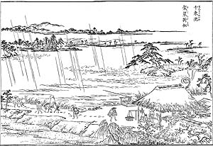
The large, gnarled pine spreading its branches over the pond is a famous tree named Kesa-kake matsu ("the robe-hanging pine") after a legend relating to Nichiren (1222-82), founder of the Nichiren Sect of Buddhism. It is said that the saint stopped by the pond and hung his robe on the pine while he washed his muddy feet and refreshed himself after a 11-day trek from his base at Mount Minobu.
Nichiren then continued on to Hommon-ji Temple, about 3 km south, where he paid a visit to Ikegami Munenaka. He intended to go on from there into Hitachi Province (now Ibaraki Prefecture), but sadly Nichiren never took to the road again. He breathed his last at Hommon-ji about a month later, on Oct. 13, 1282.
Another story suggestive of the mysterious charm of the pond tells how Minamoto-no Yoritomo (1147-99), the founder of the Kamakura shogunate, camped overnight in 1180 at Senzoku Hachiman shrine (glimpsed in the woods on the left of the woodblock print). While he was admiring the moon reflected in the water that night, a magnificent wild horse emerged from nowhere, its satin-smooth coat shining in the moonlight. Yoritomo caught the stallion, which he named Ikezuki ("Moon in the Pond"), and the steed became the shogun's beloved companion in his subsequent battles -- he rode the horse during his entry into Kamakura later the same year.
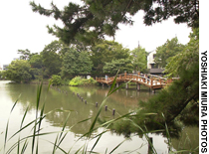
Present-day views of the pond showing Ikezuki-bashi.
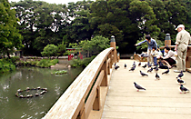
Senzoku Pond also fascinated Katsu Kaishu (1823-99), a shogunal retainer instrumental in the transition from Tokugawa rule to Meiji governance. To negotiate the peaceful handover of Edo during the Restoration War, Katsu often visited the chief spokesman of the imperial forces, Saigo Takamori, at Hommon-ji -- at that time on the city boundary. Their decisions, based on a deep mutual trust, saved Edo City from destruction in 1868.
Katsu was rewarded with a high position in the new Meiji government and upon retirement had achieved the office of minister of the Navy. Remembering Senzoku Pond from his frequent visits to Hommon-ji, Katsu had a villa built there in 1891, and he left instructions in his will that he should be buried there. Next to Katsu's grave is a monument dedicated to Saigo, in memory of their honorable friendship.
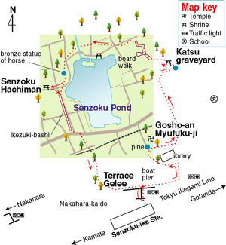
The rich heritage and scenic beauty of Senzoku Pond prompted local community leaders to set up, in 1933, a foundation devoted to its preservation, the Senzoku Fuchi Kyokai. With a view to achieving a balance between the preservation of the area's environment and the demands of encroaching urbanization, foundation members registered the pond and its environs as their property to be managed by the foundation. That the pond has retained its scenic character is largely thanks to their pioneering efforts, passed on down the years to their sons and supporters.
In 1989, the foundation donated its property to Ota Ward, entrusting the principal managerial responsibility to the municipality, while continuing with its good endeavors.
An ideal place for a leisurely stroll in any season, Senzoku Pond is a lovely place to take young children, too, to enjoy boating and bird-watching. To trace a path around the historic spots ringing the pond, cross over the highway via the pedestrian bridge in front of Senzoku-ike Station, descend to the right and then walk straight, taking the first left just before the stop light.
A quiet path by the public library leads left to Gosho-an Myofuku-ji Temple through tall metasequoias, poplars and flowering bushes. (If the path is closed, enter through the temple's roofed gate behind the library on the right.) A Japanese black pine (kuro-matsu, Pinus thumbergii) in a fenced-in circle commemorates the legendary Kesa-kake matsu, though this poor pine is in rather poor shape as it is shaded by neighboring trees.
The small temple garden, with a thick grove of large bamboo (mosochiku,Phyllostachys heterocycla), imparts a strongly spiritual atmosphere.
Exiting by the roofed gateway, go left to enter a children's playground planted with cherry trees. A quiet section on the right has a vestige of former days, with tall, rugged black pines flourishing alongside shirakashi ("white" oak, Quercus myrsinaefolia) and keyaki (Zelkova serrata). A small torii marks Saigo's memorial, adjacent to the Katsu graveyard on the right.
The nearby corner of the pond is also reminiscent of the pastoral scenery as it once was, planted with reeds and small plants that grow in mud and shallow water. Actually, this is part of an ecological rehabilitation project initiated by Ota Ward to reduce water pollution by introducing plants that absorb nitrogen and phosphorous. The plants also provide shelter for small fish, which in turn attracts herons and egrets. You don't need to appreciate all that, though, to enjoy a stroll over the boardwalk while dragonflies flit overhead and turtles float nonchalantly in the water.
At the end of the boardwalk, you can walk up a low hill planted with cherry and pine, a great place for blossom viewing in springtime. Bearing left along the pond takes you under thick, wild growths of muku-no-ki (Aphananthe aspera),eno-ki (Japanese hackberry, Celtis sinensis) and sudajii (chinquapin,Castanopsis cuspidata). Presenting a lovely contrast with the thick greenery around here is a red bridge leading to the shrine of Benten, a water goddess. This pleasing visual effect is precisely as intended by the Senzoku Fuchi Kyokai, which added the island and shrine in 1934.
Still another, more recent example of "scenic enhancement" is the three-arched wooden bridge farther around the pond. Named Ikezuki-bashi after the legendary horse, the bridge was built in 1997 by Ota Ward, which sought advice from the Senzoku Fuchi Kyokai. This classical bridge, which highlights the natural color and texture of its cypress wood, provides a perfect stage for traditional flute performances in an enchanting evening program organized jointly by Ota Ward and the Senzoku Fuchi Kyokai in May every year.
Back at the pedestrian bridge, you might wish to rest awhile at the cafe-restaurant Terrace Gelee, which serves tasty light meals and refreshments. To reserve a table, call (03) 3748-1166.

Then one day during the Kamakura Period (12th century), a monk by the name Nichiren (the founder of the Nichiren sect of Buddhism) passed by the place in his journey. He stopped by to rest and allegedly washed his legs at the pond. Henceforth, the place has been known as "洗足池" (literally, "leg-washing pond").

