Kamakura "Ebisu" Deity of Prosperity
January 1 (Mon) to January 3 (Wed) and January 10 (Wed)
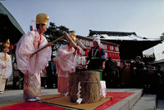

Ebisu (the god of wealth) sits with clasped hands on a rock at Hongakuji Temple in Kamakura City. It is believed that good fortune will come after he brings calmn to the world. People pray for the prosperity of their business and a good economy in the coming year. "Fuku-Musume" fortune maidens in beautiful traditional costume sell lucky bamboo ornaments ("Fuku-Zasa") during the "Ebisu-Ichi" market from January 1 to January 3 at the Hongaku-ji Temple of the Ebisu Deity. January 10 (Wed) is the day of the main "Ebisu-Taisai" festival, with the New Year "Fuku-Mochi" lucky rice cake making ritual performed from noon following the "Hon-Ebisu" Buddhist prayer service from 11:00 a.m.

