Nichiren in Kamakura
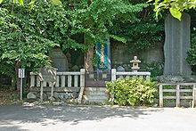
The monument on the spot at Ryūkō-jiwhere Nichiren was saved from execution
Kamakura is known among Buddhists for having been during the 13th century the cradle ofNichiren Buddhism. Founder Nichiren wasn't a native: he was born in Awa Province, in today's Chiba Prefecture, but it was only natural to a preacher to come here because at the time the city was the political center of the country^{[37]}. He settled down in a straw hut in the Matsubagayatsu^{[38]} district, where three temples (Ankokuron-ji, Myōhō–ji, and Chōshō-ji), have been fighting for centuries for the honor of being the true heir of the master^{[37]}. During his turbulent life Nichiren came and went, but Kamakura always remained at the heart of his religious activities. It's here that, when he was about to be executed by the Hōjō Regent for being a troublemaker, he was allegedly saved by a miracle, it's in Kamakura that he wrote his famous Risshō Ankoku Ron (立正安国論?), or "Treatise on Peace and Righteousness", it's here that he was rescued and fed by monkeys and it's here that he preached^{[37]}.
The locations most important to Nichiren Buddhism are:
- The three temples in Matsubagayatsu
Ankokuron-ji claims to have on its grounds the cave where the master, with the help of a white monkey, hid from his persecutors^{[37]}. (It must be noted however that Hosshō-ji in Zushi's Hisagi district makes the same claim, and with a better historical basis^{[39][40]}.) Within Ankokuron-ji lie also the spot where Nichiren used to meditate while admiring Mount Fuji, the place where his disciple Nichiro was cremated, and the cave where he is supposed to have written his Risshō Ankoku Ron^{[37]}.
Nearby Myōhō–ji (also called "Koke-dera" or "Temple of Moss"), a much smaller temple, was erected in an area where Nichiren had his home for 19 years^{[37]}.
The third Nichiren temple in Nagoe, Chōshō-ji, also claims to lie on the very spot where it all started.
- The Nichiren Tsujiseppō Ato (日蓮聖人辻説法跡?) on Komachi Ōji in the Komachi district contains the very stone from which he used to harangue the crowds, claiming that the various calamities that were afflicting the city at the moment were due to the moral failings of its citizens^{[37]}.
- The former execution ground at Katase's Ryūkō-ji where Nichiren was about to be beheaded (an event known to Nichiren's followers as the Tatsunokuchi Persecution (龍ノ口法難?)), and where he was miraculously saved when thunder struck the executioner^{[37]}. Nichiren had been condemned to death for having written the Risshō Ankoku Ron^{[41]}. Every year, on September 12, Nichiren devotees gather to celebrate the anniversary of the miracle^{[42]}.
- The Kesagake no Matsu (袈裟掛けの松?), the pine tree on the roads between Harisuribashi and Inamuragasaki from which Nichiren hanged his kesa (a Buddhist stole) while on his way to Ryūkō-ji^{[41]}. The original pine tree however died long ago and, after having been replaced many times, now no longer exists.

Ryūkō-ji (龍口寺?) is a temple of the Nichiren Buddhist sect in the city of Fujisawa, Kanagawa Prefecture, Japan. It stands on the site of the former Tatsukuchi (or Tatsunokuchi) Execution Grounds, and its name uses the same two kanji, 龍口. It was here that Nichiren, namesake of the Buddhist sect, was to have been executed. It was founded in 1337 by Nippō, a disciple of Nichiren. ^{[1]}
Major buildings at the temple include the Hondō, a five-story pagoda, a stupa(sharitō), and the Shichimendō. The cave where Nichiren was confined is preserved on the grounds. A statue of him stands in the courtyard in front of the Hondō.
Ryūkō-ji is a short walk from Enoshima Station on the Enoshima Electric Railway, and from Shōnan-Enoshima Station on the Shonan Monorail.

. Le temple Ryuko-Ji 竜口寺:
Ce temple se trouve sur le continent au pied des collines Shichirigahama. Lorsque l'on arrive de Kamakura par la ligne Enoden, on aperçoit le temple au niveau d'un carrefour juste avant la gare d'Enoshima. Ce temple est perdu dans la végétation et il est très peu visité par les touristes. Ce temple fut érigé par Nichiren (1222-1282) fondateur de la seule secte bouddhique japonaise. Ses nombreuses critiques envers le shogunat lui avaient valu la condamnation à mort à laquelle il échappa. On pénètre dans l'enceinte de ce temple en traversant une porte qui possède de superbes panneaux de bois sculptés, représentant la vie de Nichiren. Au-dessus du temple, perdu dans une végétation luxuriante, se trouve une pagode en bois de 5 étages. Un petit sentier part à l'assaut des collines, mais il faut faire attention aux toiles d'araignées et à celles-ci, très nombreuses.
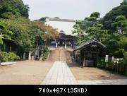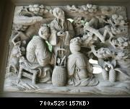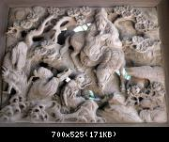

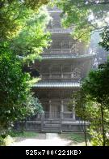

Historical Overview
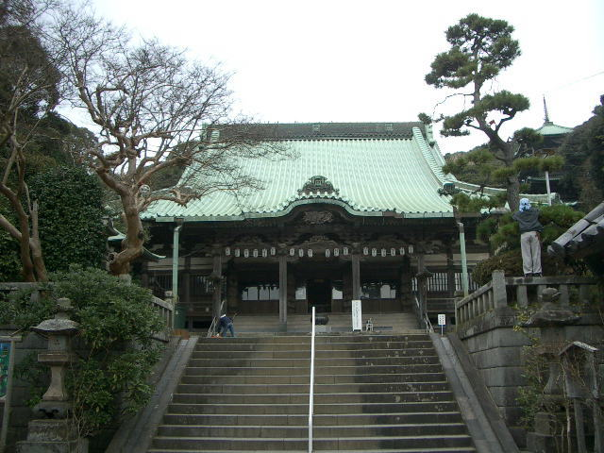
The Temple's site used to be an execution ground for criminals during the Kamakura Period (1185-1333), and its monuments stand at the left-hand side of the Temple's outer gate.
Priest Nichiren (1222-1282), the founder of the Nichiren Sect, stayed in Kamakura for nearly 20 years and was engaged in missionary work to promote Buddhism, emphasizing the importance of the Lotus Sutra. His adoration to the Lotus Sutra was so intense that he constantly attacked other sects' doctrines criticizing them as heretical or dissent from legitimate Buddhism. His harsh criticism provoked hostility toward him not only from other sects Buddhists but also from the Shogunate authorities. As a result, he had to face persecutions four times during his stay in Kamakura, and in the last case of 1271, he was sentenced to death by beheading as he accused the Shogunate of not employing his doctrines.
On September 12, 1271, Priest Nichiren was brought here for the execution. No one doubted he would die within hours. However, the moment an executioner was about to strike his neck with a sword, asserts the legend, a tremendous clap of thunder roared the area with a streak of lightning. Aghast and petrified, the executioner was no longer able to behead the Priest. He thought it was a miracle wrought by the Priest. (The Priest performed a various miracles and was revered as a miracle worker by millions like beautified Christian saints.) Messengers were sent to the Shogunate office to tell them what had happened. When they came up to a stream called the Yukiai River, roughly 2,000-meter east of the Temple, they met with another messengers who were dispatched by Tokimune Hojo (1251-1284), then the Eighth Regent. The Regent's messengers were on the way to tell them not to execute Priest Nichiren. Since the two groups met here by accident, the river was thus named the "Yukiai-gawa," or the River of Meeting.
The execution was suspended immediately and Priest Nichiren was exiled instead to Sado Island off the coast of Niigata Prefecture. (Some say that the Regent gave a special pardon to Priest Nichiren as the Regent's wife turned out to be pregnant).
A picture of Priest Nichiren in exile on Sado at MFA.
Sixty-six years later on this historic spot, a priest named Nippo, Priest Nichiren's adherent, made a hermitage to dedicate it to the memory of the great Priest, in which he enshrined a statue of Priest Nichiren he carved himself. From then on, the Temple gradually gained momentum supported by the devout and expanded its structures.
However, the Great Kanto Earthquake in 1923 destroyed nearly all of the Temple structures except for the main hall and the five-story pagoda. All others were rebuilt afterward.
The Temple ranks among the 44 head temples of Nichiren sect.
- Hondo, or Main Hall
- (alsocalled shikigawa-do)
The present hall, 29 by 32 meters, was rebuilt in 1818 and one of the largest in Kamakura. Shikigawa denotes a leather mat on which Priest Nichiren sat waiting for the execution. Since Priest Nippo erected the original hermitage, it has been called shikigawa-do. Today, the stone on which shikigawa was laid is kept at the center-left of the hall as a temple treasure. In contrast to other sect temples like Zen, inside the hall of Nichiren sect temples is highly decorative ornamented with many carvings and decorations hanging down from the ceiling.
In the center are a group of statues and the Odaimoku Tablet inscribed with the letter "Nam-myo-ho-ren-gek'kyo," often seen at other Nichiren Sect temples. In the right-hand recess are six statues of those who were Priest Nichiren's immediate disciples. Unlike other Nichiren sect temples, the door is usually open and casual visitors are allowed to go into the hall, even get close to the statues in case religious services are not taking place.
(2) Five-story Pagoda
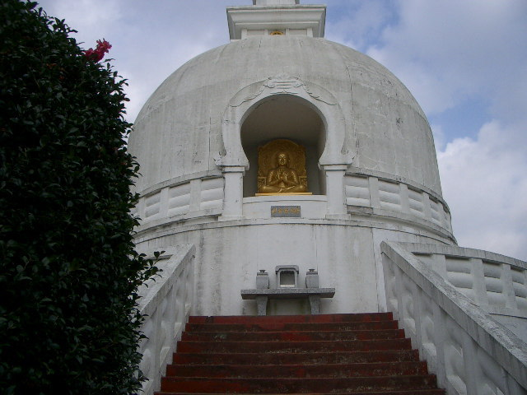
At the right of the main hall is a flight of about 50-step leading up to the pagoda. The only five-story pagoda in Kanagawa Prefecture was built in 1910 by an architect who specialized in temple and shrine construction, and founded a top-ranking construction company in today's Japan. It was made of keyaki zelkova trees, and survived the Great Kanto Earthquake of 1923. Pagoda originally meant the spire towers of Hindu temples in India.
Japanese pagodas have long been known as being resistant to earthquakes and scholars are mystified about why these tall wooden building are so stable. In fact, there are roughly 500 pagodas in Japan, which remain standing for centuries in a land often shaken by quakes, and few collapsed. To name a few, Toji Pagoda located near Kyoto Station measuring 55-meter high and the highest of its kind has been standing since 1644. Horyuji pagoda in Nara was originally built in 607 and is the oldest multi-story wooden structure in the world.
Whereas the Chinese pagodas are mostly made of stone, Japanese built them with wood on their own design. They have extended eaves and there are no staircase connecting each floors. An intricate woodwork. In this pagoda of the Temple, statues of Priest Nichiren and others are enshrined on the ground floor.
Meanwhile, a 634-meter(2,080 ft)-high TV tower for upcoming digital broadcasting is now under construction at Sumida ward in Tokyo, which uses central pillar technology employed by many pagodas to be quakeproof. The tower is called Tokyo Sky Tree. For Japanese, the height is easy to memoraize as the figure 634 is mu (6) sah (3) shi (4), and Musashi is the old name of Tokyo. The tower is scheduled to be completed in spring of 2012.
(3) Shichimen Daimyojin Shrine
Up a flight of about 80 steps at the left side of the main hall is a shrine called Shichimen Daimyojin. This is the guardian deity of the Temple and a typical example of syncretism. To be precise, Shichimen Daimyojin is the guardian deity of Kuonji situated in Yamanashi Prefecture, the headquarters of all Nichiren sect temples, and therefore, the one here is its sub-shrine.
Legend holds that a young lady beautifully dressed often appeared out of nowhere when Priest Nichiren was reciting the Lotus Sutra in Kuonji and she enthusiastically listened to his recitation. One day, the Priest asked her who she was. She said she was a celestial nymph living in a pond near Mt. Shichimen and would like to get salvation from various sins and agonies by listening to his Lotus sutra. But, Priest Nichiren had known who she was. For a trial, the Priest put a vase in front of her. Her reflection on the vase revealed that she was a red dragon. Priest Nichiren instructed her to get back to the pond and to be a guardian deity of Kuonji. Being identified, the red dragon went back to the pond. Ever since, she, or the red dragon, turned guardian deity of Kuonji, guarding at the southwestern corner (believed to be the rear Demon's Gate) of the temple.
(4) Bussharito, or Buddha's stupa (Picture; above, right)
Further up the Shichimen Daimyojin, the path leads off to a clearing, a good vantage point to view the sea coast. On the other side of the clearing is a whiteBussharito. Built in July 1970 by Nittatsu Fujii (1885-1984), a wealthy Nichiren Buddhist, in commemoration of the 700th anniversary of the Priest Nichiren's deliverance, it is of traditional Siamese style. Busshari is literally Buddha's ashes or relics and Bussharito is a tower to house Busshari.
The clearing commands a wide view of the south toward Enoshima as aforementioned. In 1919, Iso Mutsu (1867-1930), an English woman who married a Japanese diplomat, described the beauty of the area as follows in her book Kamakura: Fact and Legend: Quote. The picturesque grounds---upon an extensive and parklike scale--- extend over surrounding hills which command a feast of beauty and color. The green heights of Enoshima lie like a jewel in the rich blue ocean below, spangled with sails of countless white-winged ships and boats plying the waves; the distant mountains, with an uninterrupted view of Mt. Fuji, blend into a serene picture justly named for its romantic character. Unquote.
In the Edo Period, many travellers visited Enoshima area and its beauty was painted by a host of artists. Here is one of them owned by MFA.
By contrast, what we see today at the same spot is quite different. The hill is overgrown with grass, and the Enoshima coast is far from beautiful with many ugly buildings and shabby houses standing close together. Mt. Fuji can rarely be seen due to air pollution.
(5) Daisho-in or the guest house
Connected with the main hall by a corridor is a magnificent wooden building with triple-deck roofs. The structure used to be a house called "Sericulture Palace" located in Nagano Prefecture. By the contribution of Nichiren sect devotees, the palace was relocated here in 1923 shortly after the Great Kanto Earthquake.
(6) Holy cave (Picture, below)
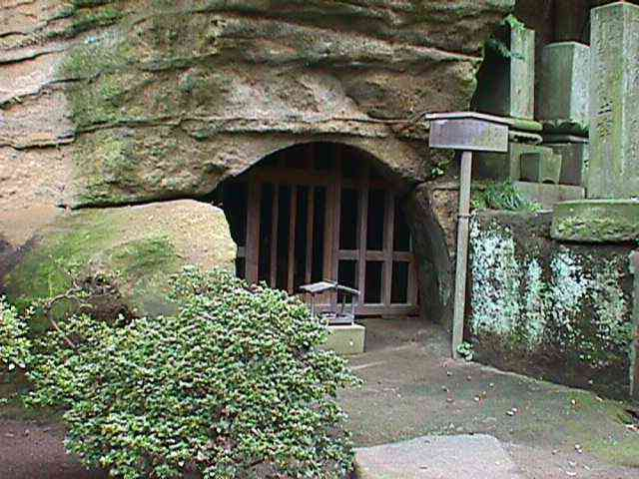
The night Priest Nichiren was almost beheaded on September 12, 1271, he stayed in this small, 7-square-meter cave on the edge of precipice at the southwest corner of the courtyard. With heavy wood grills, it is preserved by the Temple as the Priest's Holy Cave.
(7) Myokendo
Myoken is a Bosatsu or Bodhisattva of Big Dipper or the divinized Big Dipper (Sudrsti in Skt). In ancient days, navigators relied on the Big Dipper like a compass, whereby navigators, merchants and those who gained profits by sea transportation began to worship the Big Dipper as the god, or Bodhisattva of safe voyage, calling it Myoken Bosatsu.
Myoken has also been respected as the god of healing eye-disease. Legend has it that this Myoken Bodhisattva once appeared before Priest Nichiren and because of this legend, Myoken Bodhisattva is closely associated with Nichiren sect temples.
(8) Public execution site
The site of public execution is seen to the left of the front gate, where tens of thousand criminals were beheaded right here centuries ago. A Gorinto (Five-element stone tower) was donated by the Nichiren followers to commemorate Priest Nichiren's persecution.
Annual Observances:
The memorial service for Priest Nichiren takes place on September 11 through 13 every year. The Temple treats visitors with rice-cake dumpling covered with sesame paste in commemoration of the nun at Joeiji who gave the dumplings to Priest Nichiren on his way to the execution site. It is called Botamochi in Japanese and usually covered with sweet bean paste. However, the dumplings here are covered with sugar-free sesame paste, same as the one Priest Nichiren was treated with. Legend asserts that when the nun tried to give her Botamochi to Priest Nichiren, there was no plate to put her offerings on. Instead, she used a circular lid of her cooking pot or Nabebuta. Moved by her thoughtfulness, Priest Nichiren inscribed on the wooden lid a text of scriptures. This inscribed wooden lid was later called "Nabebuta mandala" and has been preserved as a temple's treasure.
Notes:
- Soon after the Pacific War broke in 1941, the government ordered Japanese to donate bronze and iron materials to help boost weapon production. The bell in the Temple was the first to be donated. The present bell was cast, therefore, after the war.
- In the neighborhood of the Temple, there are eight Nichiren sect sub-temples, and chief priests of these sub-temples used to take care of the Temple in rotation until 1886. In other words, the Temple did not have its own chief priest during the most of the Edo Period (1603-1868). Among those sub-temples is Joryuji situated just behind the Temple, where a cenotaph stands for the repose of five Mongol envoys who were executed here in 1275. They came to Japan following the order of Kublai Khan (1215-1294), grandson of Genghis Khan (1167-1227), and proposed Japan become their tributary state. Tokimune Hojo, then the Eighth Hojo Regent, not only decline the offer but he even executed the envoys. The cenotaph was erected in 1925 to commemorate the martyrs on their 650th anniversary of death. Mongolian Ambassador to Japan often visits here to mourn for the victims.
- In Enoshima off the coast of the Temple, one of the three largest Benten (Sarasvati in Skt.) shrines in Japan is located. Believe it or not, the island is dubbed "Mont St. Michel of Japan" and the beach "Miami of Asia" by the locals.
- The Temple district is called Tatsunokuchi, or the Mouth of Dragon. The surrounding hills look like a dragon and the Temple site like the dragon's mouth. Hence the name of "Mouth of the Dragon." In Chinese characters, "Tatsunokuchi" is also pronounced "Ryuko" and the namesake of "Ryukoji."
- The Temple can be reached without walking much if you get off at Fujisawa Station of the East JR's Tokaido Line and change for Enoshima of Odakyu Railways. Get off at Enoshima Station and the Temple is within 10 minutes walk. Or, get off at East JR's Ofuna Station and change for Enoshima by Shonan Mono-Rail, of which Enoshima Station is even closer to the Temple.

